Volume

1

JAMES COOK UNIVERSITY

Non-Invasive Current Transformer

CT M-3501

User Manual

JAMES COOK UNIVERISTY

CTM-3501 USER MANUAL

© James Cook University

12345 University Drive • Bld 14

Clinton Elliott

Michael Giorgas

Townsville, QLD 4814

Phone 203.555.0167 • Fax 203.555.0168

T A B L E O F C O N T E N T S

INTRODUCTION 1

SAFETY 2

PACKAGE CONTENTS 3

1. CTM-3501 Device 3

2. Base Station 4

3. Viewing Station 5

HARDWARE INSTALLATION 6

1. Locate Your Meter Box 6

2. Connect to Selected Cables 6

3. Connect CTM-3501 Device 7

4. Setup Base Station 8

VIEWING STATION SETUP 9

FAQS 10

Why when I disconnect the Raspberry Pi from my computer it stops monitoring? 10

Why has the Raspberry Pi not connected yet? 10

Why am I not seeing any green lights on the Raspberry Pi? 10

Why is my current very high? 10

Why is the Raspberry Pi not receiving any data? 10

TECHNICAL INFORMATION 11

Setting Up the Putty Application 11

Setting up the Raspberry Pi with a Static IP 12

Changing Raspberry Pi Setting for more power 12

Setting up an Internet Connection 13

How to use the Command Line 14

How to connect the Raspberry Pi to a virtual screen 14

Chapter

1

# INTRODUCTION

We recommend the installation by a licensed Electrician.

Energy metering and monitoring are at the heart of energy management, understanding when and where your energy is consumed is the key to saving you money. The need for power monitoring has become more important in the home as the strive for efficiency has come to the forefront.

The CTM-3501 provides the consumer a wireless electricity monitor for the household which shows the amount of energy being consumed with a near-to-real-time display uploaded to the internet. You can walk around the home switching appliances on and off to see the difference that each one makes. With a few small changes in your consumption behaviour, the CTM-3501 can help you find the perfect energy solution for your home.

Note

For different voltages refer to website www.ctm-3501.com

# SAFETY



It is important that you take some simple precautions before using this product. Incorrect use or poor safety practices can result in injury or fatality. Whenever possible, turn off the main breaker, outside your home feeding power to your electric panel.

When installing the ctm-3501 monitor you should find that everything is straight-forward. However, there are a number of important health and safety issues which you need to be aware of:

* CT sensors clip fit onto the internal live feed cables inside the electricity box, which delivers the live supplies to your home.
* Do not touch any metallic connections during the installation of the CT sensors. Do not carry out this installation if under the influence of alcohol or drugs.
* Water is a conductor. To avoid electric shock, keep all cords dry and clear of water or damp areas. Do not install CTs if standing in water or during floods.
* Remember the device is non-intrusive and does not require rewiring; no wires or cables need to be cut, removed or modified to perform this installation. If you notice anything unusual about the electricity supply such as loose wires, exposed cabling, burn marks, holes in the insulating materials, damage to the electric wires in the service panel or at the point of CT attachment, stop immediately, and report the findings to your supply company.
* In Australia the live cable can only be accessed by qualified electricians.
* Do not force or bend the cables at any point during installation. If you are worried or have any concerns about the installation, please contact a qualified electrician immediately.

# PACKAGE CONTENTS

Check to ensure all CTM-3501 package contents have arrived:

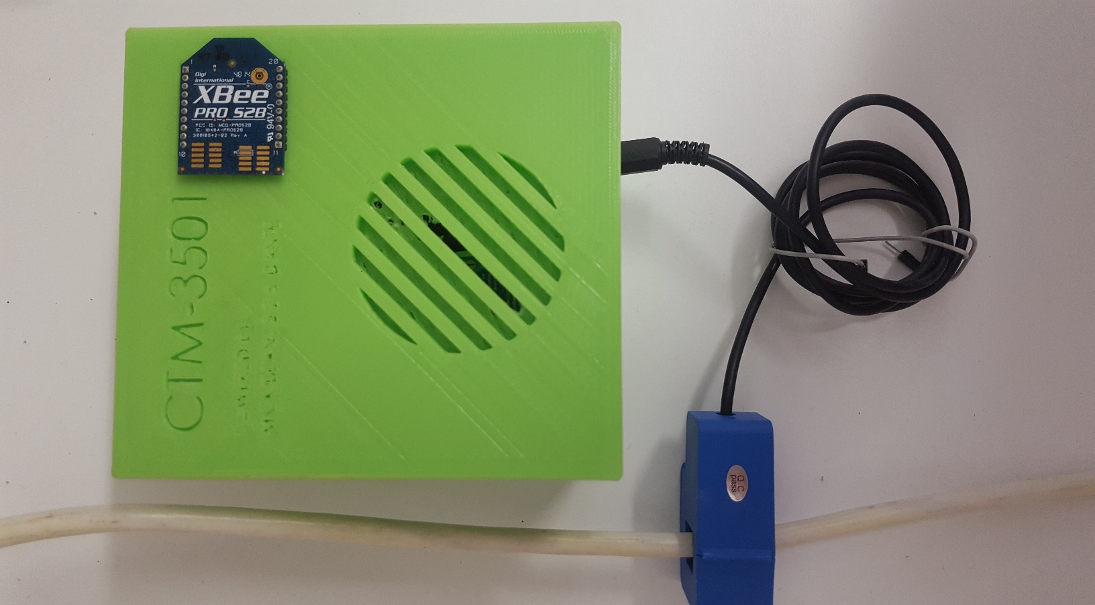

**D**

**B**

**A**

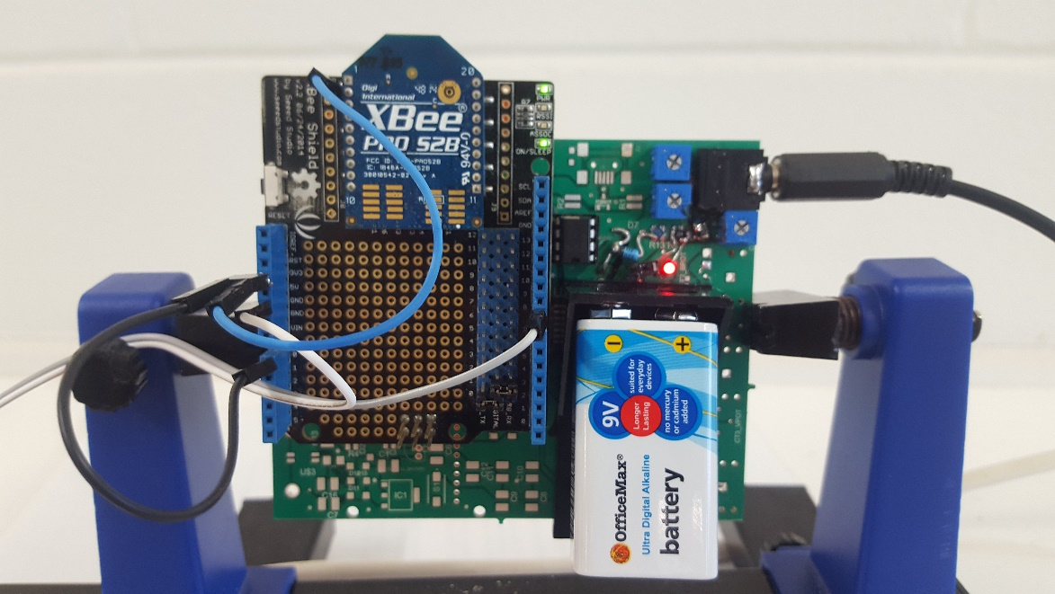

**c**

### CTM-3501 Device

1. 1 x CTM-3501 Case
2. 1 x 10A Current

Transformer

1. 1 x 9V Battery
2. 1 x ZigBee (Coordinator)



Check to ensure all Raspberry Pi package contents have arrived:

### Base Station

1. 1 x Raspberry PI
2. 1 x Power Cable (not shown)
3. 1 x Wi-Pi
4. 1 x Ethernet Cable
5. 1 x Ethernet-USB Adaptor (if required) (not shown)
6. 1 x ZigBee Router
7. 1 x ZigBee Cable
8. 1 x SD Card

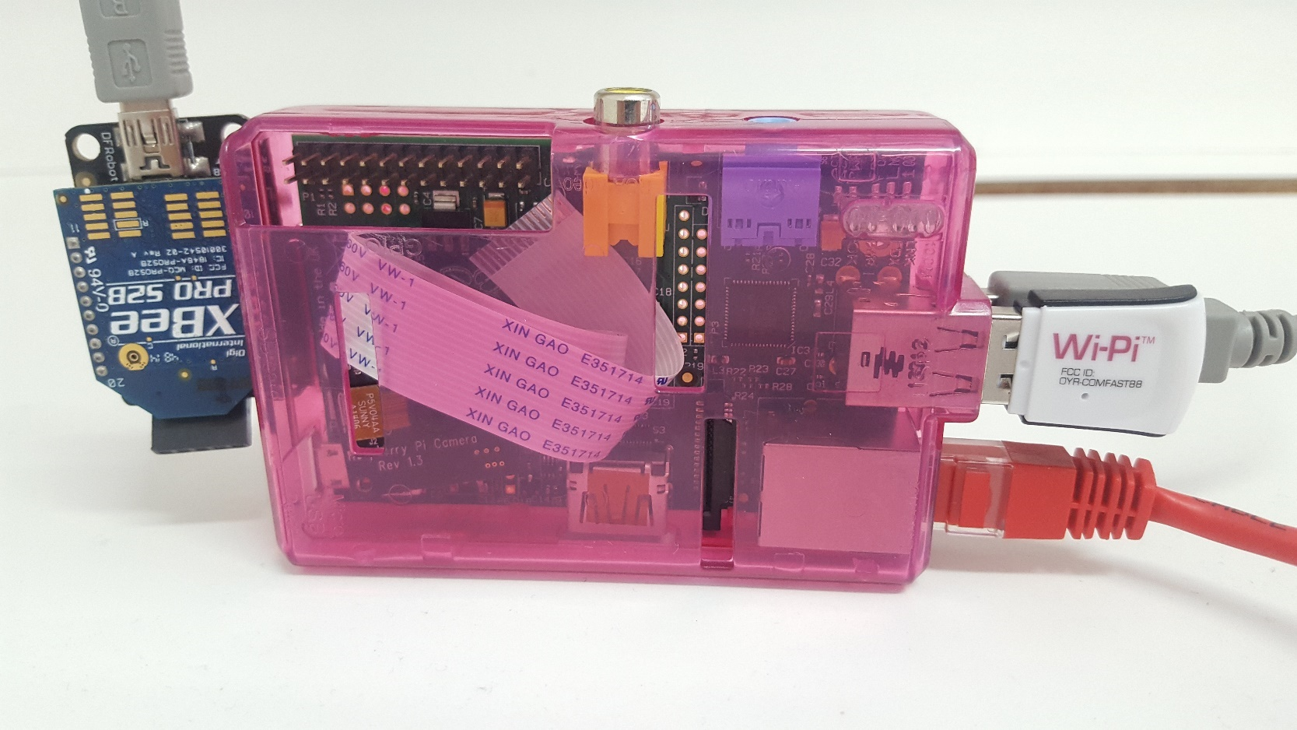

**G**

**C**

**D**

**A**

**F**



Check to ensure that you have adequate devices:

### Viewing Station

1. 1 x Computer (or similar device)
2. 1 x Router Connect to Internet
3. 1 x Installed Putty Program

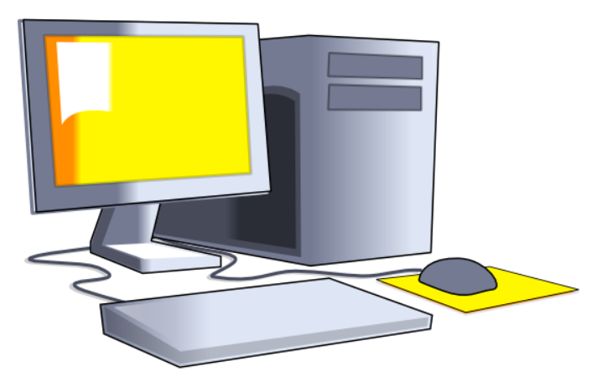

**A**

**B**

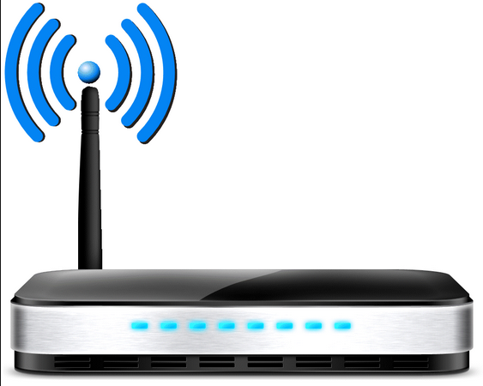

**B**

Note

The CTM-3501 can be routed via hot-spotting on Android.

# HARDWARE INSTALLATION

The CTM-3501 is installed by clipping the CT sensors around the feed wires in your main switchboard. In Australia the standard residential voltage is 240V.

Note

Note - For a 240V panel (typical residential electric panel) power is measured using one CT sensor. For different voltages, please change during the Monitor Setup stage (see website). If in doubt, contact an electrician or other qualified person to assist you with the installation of the CT sensor.

1. 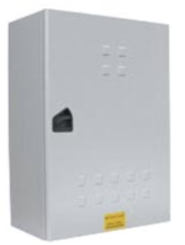Locate Your Meter Box

Locate your electricity meter and determine its type. You

can normally find this on an outside wall, in the garage,

basement or utility room. If you live in a flat, it can often

be found outside your front door, in the communal

stair case, or in the basement. Ensure there is enough

of the accessible cable coming from the bottom of your

electricity meter.

1. Connect to Selected Cables

You should find cables exiting the meter, the main feed cable is the live

cable exiting from the meter. Connect the CT sensor to the main cable or to the circuit desired to be measured as shown in the figure.

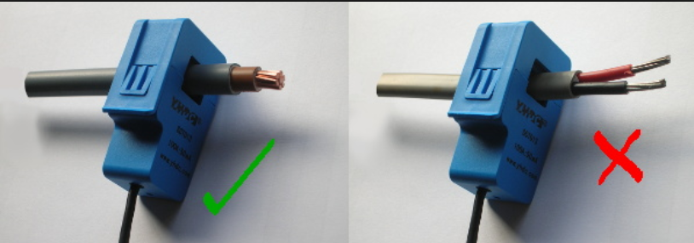

1. Connect CTM-3501 Device

Insert the jack on the end of the CT sensors wire into any of the four input sockets on the CTM-3501 device. The CT sensors act as a current sensor and relays the current

being drawn on the selected cables to the base station. Mount the CTM-3501 device

on the wall next to or above the meter box and ensure it is in a safe location from movement or the environment. This will make it easier to replace the batteries

(although the batteries will last for a long time). If the panel is in a finished area, you may mount the transmitter inside the meter box. This may reduce transmission distance. Replace the panel cover(s) when finished installing the CT sensors.

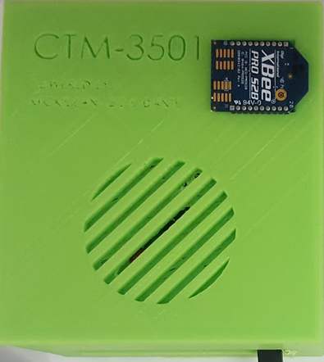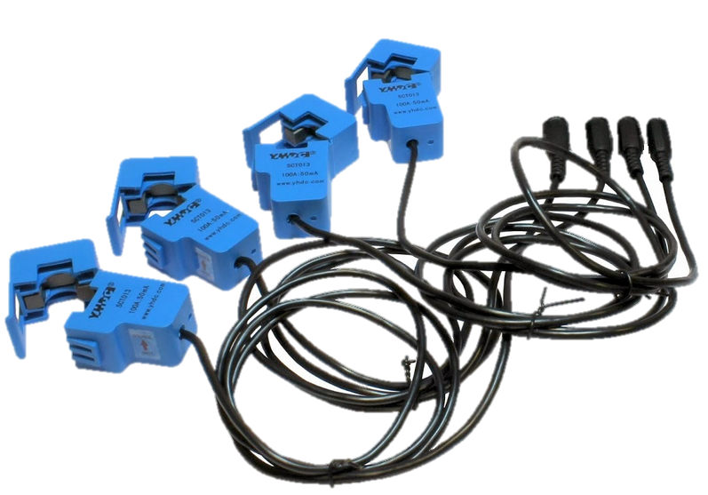

1. Setup Base Station

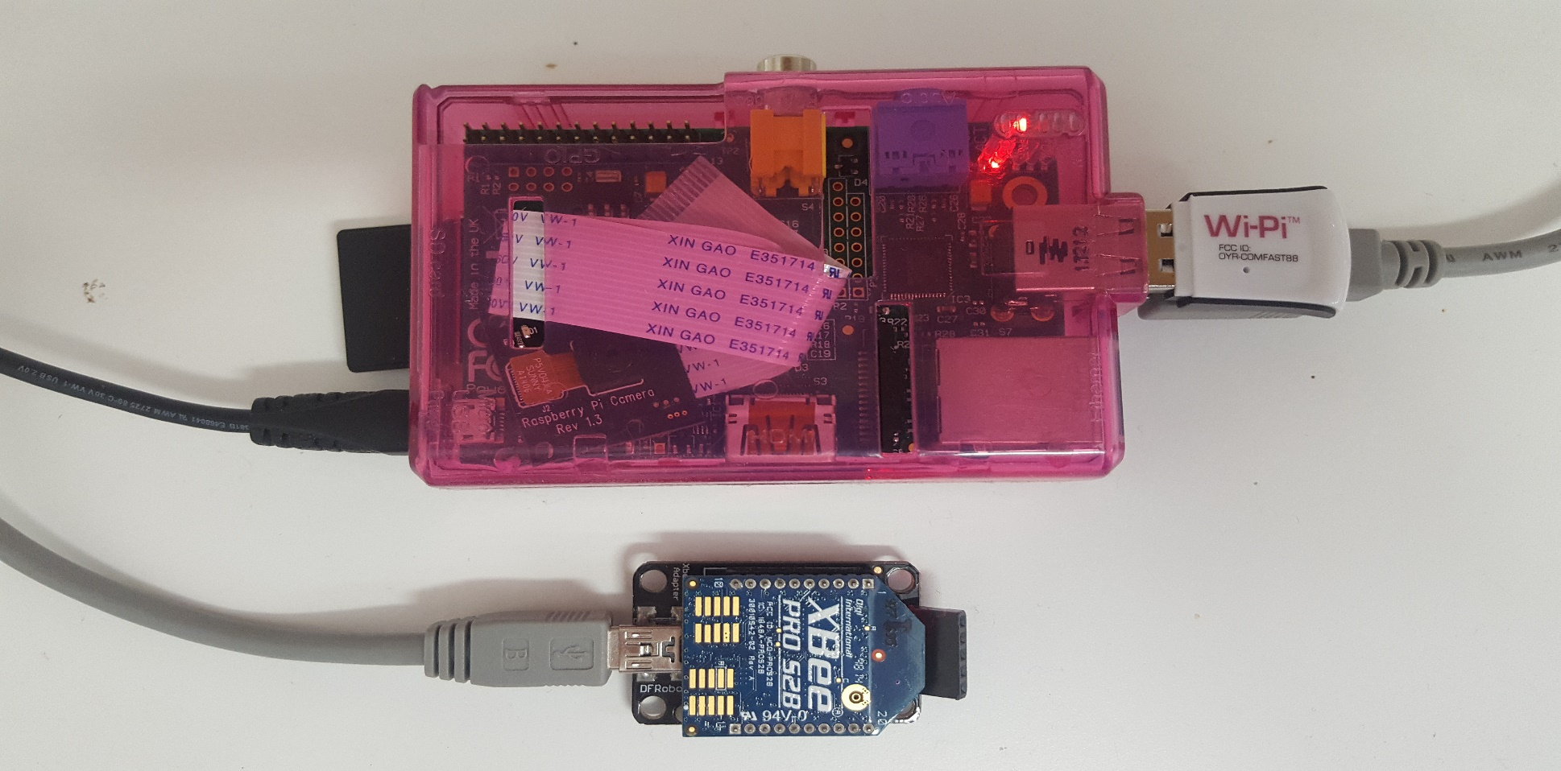

1. Insert the Wi-Pi dongle.
2. Connect the XBee via its cable to the Raspberry Pi.
3. Connect the power cable to the Raspberry Pi, insert it and switch 230V mains power.
4. Check to ensure the red light turns on.
5. Ensure the SD card is inserted straight.

# VIEWING STATION SETUP



1. Connect computer USB 2.0 to Raspberry Pi via Ethernet (use adaptor if necessary)
2. When flashing green lights appear on the Raspberry Pi open the Putty Application
3. Connect to Pi

* Username: pi*
* Password: pi* (default)

1. Connect to internet by entering (if not already connected)

* Ifdown wlan0*
* Ifup wlan0*

1. Navigate to Directory

* cd ctpi/build*

1. Run Program

* ./main /dev/ttyUSB0*

1. To Monitor Power go to

* @http://ctm-3501.com/

Note

See troubleshooting for more information about internet connection options. *Denotes it must be run at command line Putty window. See Screen Application.

# FAQS

Why when I disconnect the Raspberry Pi from my computer it stops monitoring?

When the SSH session is terminated, the result of this network disconnection is that your SSH shell session will also inadvertently kill any processes running. To run the program on a virtual screen, follow the steps in the technical information.

Why has the Raspberry Pi not connected yet?

Make sure the Raspberry Pi board is switched off, make sure your SD card is in the Raspberry Pi securely. Plug in your WI-PI dongle to a USB port on the Raspberry Pi. Connect your ethernet cable to your computer and to the Raspberry Pi. Plug the wall power adapter into the Raspberry Pi and the wall socket, and ensure the power is turned on. Once the power is connected to the Raspberry Pi it will be on. The Raspberry Pi is a small computer and you should ensure it is shut down using the *sudo shutdown -h now* or *sudo halt* command.

Why am I not seeing any green lights on the Raspberry Pi?

Repeat the steps for no connection above. If green lights do not appear after a couple of minutes, contact the customer service phoneline on (+61) 1800 989 765 or via email at MostafaRahimiAzghadi@jcu.com.

Why is my current very high?

Turn off all active appliances in the household. If the current appearing on the display does not drop, immediately call a licensed electrician.

Why is the Raspberry Pi not receiving any data?

Before continuing make sure the ethernet cable is connected and you can ping out from the Pi: using the command *ping 8.8.8.8.*

From the command line run *sudo nano /etc/network/interfaces* to check that your network name appears on the screen. Ensure that the network name and password are correct if the network name does not appear or is incorrectly entered contact the customer service phoneline on (+61) 478 14349

# TECHNICAL INFORMATION

Setting Up the Putty Application

1. Save the download to your C:\WINDOWS folder.
2. Double-click on the putty.exe program or the desktop shortcut to launch the application.
3. Enter your connection settings: ...
4. Click Open to start the SSH session.

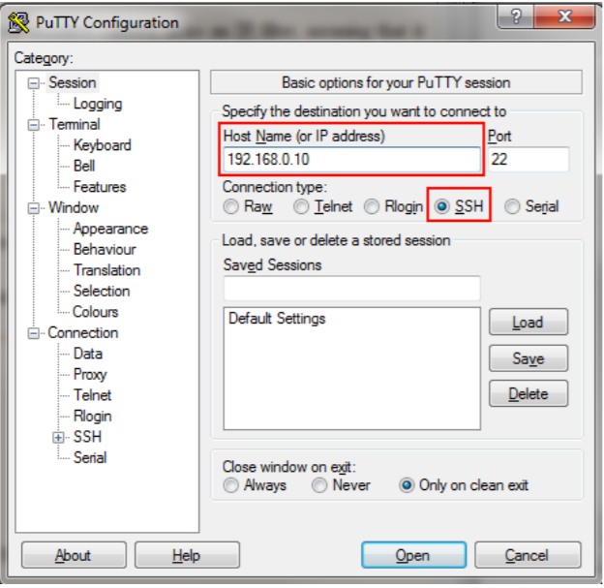

Setting up the Raspberry Pi with a Static IP

Your Pi is preconfigured with the following settings:

Setting Value

IP Address 192.168.0.10

Username pi

Password pi

You will need to configure your laptop’s ethernet adaptor to have the static IP address 192.168.0.1 with subnet mask 255.255.255.0. For Windows users, go to the start menu and search for Network and Sharing Center, and then click on change adapter settings on the left. Right click on your Ethernet or local area connection and click properties, then scroll down to TCP/IPv4 and click properties. Fill out the IP and subnet as shown.

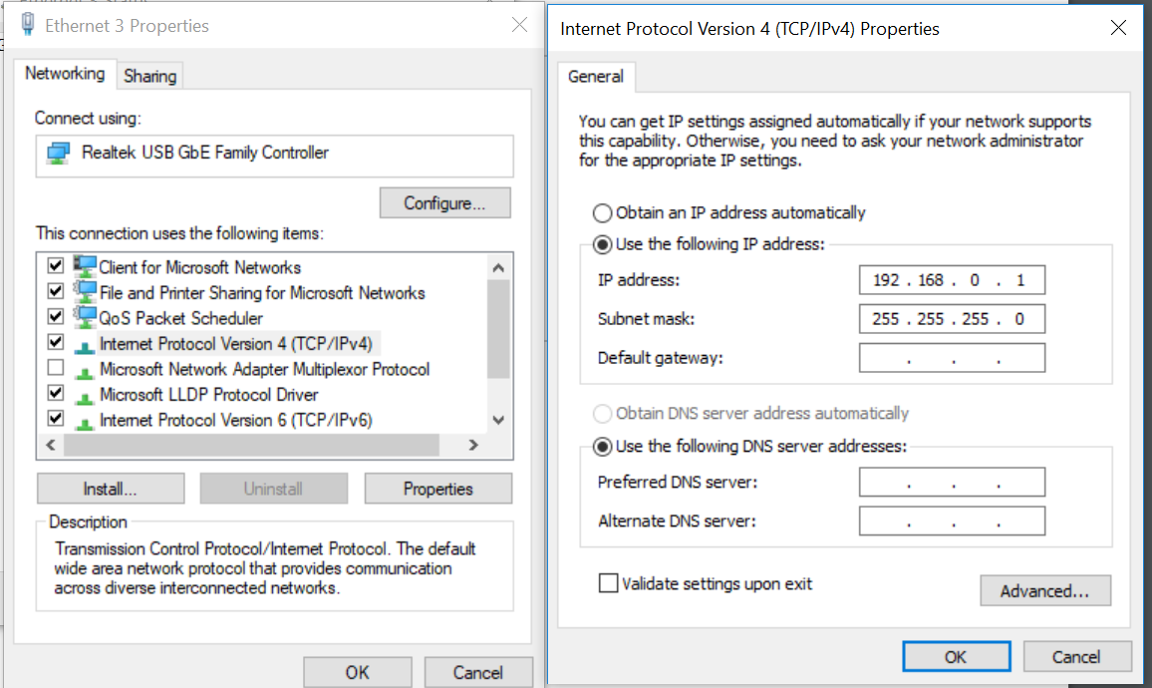

Changing Raspberry Pi Setting for more power

To get more power from your Pi try:

*sudo nano /boot/config.txt*

and enter at the bottom.

safe_mode_gpip =4

max_usb_current=1

Setting up an Internet Connection

1. Boot your Raspberry Pi without the Wi-Pi™ module connected. Connect to your Pi via an SSH/Telnet client such as Putty.
2. Type the following command:  *sudo nano /etc/network/interfaces*
3. This opens the default Linux text editor, ensure that you have an existing ethernet configuration that looks as shown.

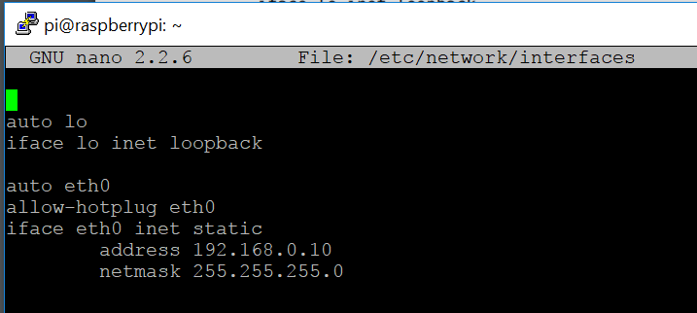

1. Edit the WIFI configuration file to match below.

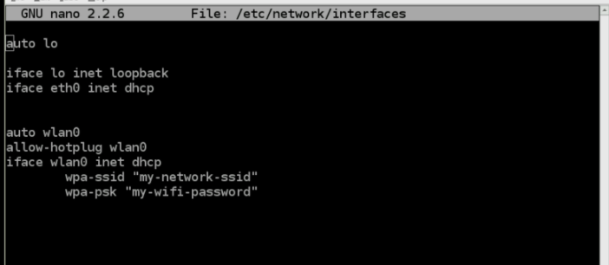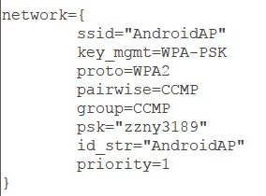

1. When you have finished press [ctrl]x. This will ask if you want to save the modified files.
2. Reboot your Raspberry Pi using the command *sudo reboot*. Plug the Wi-Fi adapter in and re-start. You should find that the Raspberry Pi connects using the Wi-Fi adapter as it boots up.
3. Try *Sudo apt-get install wicd-curses* and after installation *sudo wicd-curses* for better navigation and display of WIFI options.

How to use the Command Line

1. Connect to your Pi via an SSH/Telnet client such as Putty
2. You should be able to see the following prompt: *pi@raspberrypi ~ $*
3. 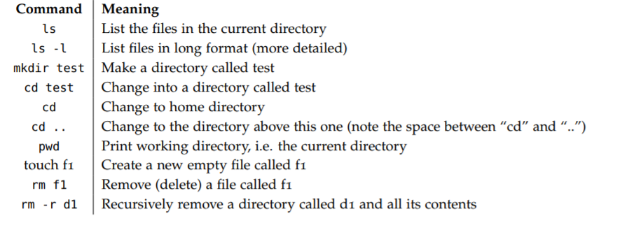Some common Linux commands that you may find useful are shown below and experimentation is recommended.
4. Other Useful Commands include:

*Ctrl + K* (cut into buffer) and then *Ctrl + U* (to paste buffer)

*Ctrl + R* (searches)

When checking internet settings: *iwconfig* and *ifconfig*

How to connect the Raspberry Pi to a virtual screen

1. Install by typing in the command line *$ sudo apt-get install screen*
2. Then, to use it, type… screen bash
3. To detach this terminal session, press CTRL + A     release, and then press   D
4. You can list all open screen instances and their status by typing…  
   screen -list
5. You can reconnect with typing screen -r
6. To end a terminal instance, you need to be in that instance, then  
   CTRL + D
7. To name a screen: *screen -S “insertname”*. To delete: *screen -X -S [name] quit*